Battle Creek VA Medical Center

Bld 24 Rm 121 PIV Office

STATEMENT OF WORK

1.0 GENERAL SCOPE
The Veterans Health Administration (VHA) has a requirement for healthcare furniture for the Battle Creek Michigan campus that meets the VHA IDIQ specifications and high-quality threshold while integrating excellent environmental stewardship.
This requirement includes healthcare furniture, design, furniture removal, professional installation and maintenance to include warranty services. Services required are detailed in SV1 Healthcare Furniture technical requirements per VHA Healthcare Furniture multiple award IDIQ.
Healthcare furnishings include:
1. case goods and modular desks, filing and storage systems, seating, tables/carts, furniture accessories and related services
2. The contractor shall provide all labor, materials, equipment, transportation, and supervision necessary to satisfy the needs of each ordering activity.

2.0 PERFORMANCE REQUIREMENTS
The contractor shall provide and be responsible for the technical assistance, development and generation for final specifications.
Furniture will be delivered and installed at the Battle Creek Campus, building 24, room 121. The address is 5500 Armstrong Road, Battle Creek, MI 49037. This is located on the first floor. Delivery is required TBD.
Duty hours will be 8:00 am – 4:30 pm. The Government recognized US holidays are: New Year’s Day, Martin Luther King, Jr. Day, Presidents Day, Memorial Day, Juneteenth, Independence Day, Labor Day, Columbus Day, Veterans Day, Thanksgiving Day and Christmas Day. If the holiday falls on Sunday, it is observed on Monday.
The contractor shall:
- Coordinate and provide project management of all products and services to manage, design, order, ship, deliver and install new furniture from the manufacturer until final acceptance by VA Interior Designer, Hannah Minjeur.

- Have on site staff supervisor with OSHA 10 certification.

- Disseminate, relocate, or scrap existing furniture in Building 24, First Floor. All existing furniture is to be removed. The Interior Designer will decide if any existing furniture will be kept and that furniture will need to be moved to the Building 85 warehouse.

- Project phasing and scheduling requirements to include design, planning, manufacturing, project management and installation.

- Only include products specified within the IDIQ.

- Prepare and provide as built furniture drawings in PDF and AutoCAD.

- Provide maintenance manuals for all products specified.

3.0 KICKOFF MEETING
The prime contractor shall participate in a kickoff meeting within ten (10) days of task order issuance, in person at Battle Creek Michigan, building 24 room 219 or via Skype, Teams or Zoom meetings. Time and date will be determined by VA Point of Contact.

4.0 SUBMISSION OF QUESTIONS
Questions: All questions must be received by July 31st, 2023. All questions submitted for this solicitation must be electronically sent to the following email address: kellie.konopinski@va.gov and Ghazal.Jones@va.gov. Questions received after the stated date and time, may be addressed at the discretion of the Contracting Officer.

5.0 SUBMISSION OF QUOTATION

Quote Submission: The contractors shall submit complete emailed electronic copy portable document format (.pdf) or Microsoft Excel (.xls) format of:

VOLUME 1: (TECHNICAL)
- drawings, (floorplans, isometrics, shop drawings, typicals etc.)
- complete manufacturer’s product specifications
- Bill of Materials tagged per CLIN/ floorplan department and room etc.
- quantity of man hours for labor/installation
- product literature
- physical finish samples
- sustainability certification documents
- complete testing results / certificates
- warranty.
- Self-certifying statement confirming ability to meet project deadlines
VOLUME 2: (PRICING)
- price quote with separate line for labor/installation
- Bill of Materials with subtotals and tagged per CLIN/ floorplan
Submissions can be sent in multiple emails to avoid computer system email size limitation, to ghazal.Jones@va.gov and Kellie.Konopinski@va.gov by 8/7/2023 by 5pm Est.
Quotes submitted by any other method will not be considered. All proprietary information shall be clearly marked. The use of hyperlinks in quotes is prohibited. Late quotes will not be accepted for evaluation. The contractor is responsible for confirming the Government’s receipt of the contractor’s quote.

PRICING MUST BE WITHIN THE ESTABLISHED IDIQ PRICING.

6.0 EVALUATION CRITERIA
TASK ORDER WILL BE EVALUATED ON:
- Bill of Materials with subtotals and tagged per CLIN / floorplan department and room etc.
- PDFs of detailed and dimensioned: Plan, 2-D and 3-D drawings of each workstation (and/or) products with multiple parts list to represent exactly what is being included in task order and to determine accuracy.
- Cut sheets with product detail for each line item.
- Labor/Services appropriate to the scope of work. (no pricing included)
- Project staffing plan appropriate to scope of work
- Project management plan appropriate to scope of work
- Sustainability Certification

7.0 PRODUCT
GENERAL

All finished surfaces shall be free of scratches, mars, dents, or blemishes, and withstand staining, and exhibit to flaking, cracking, or loss or adhesion.

Furnishings shall have smooth finishes with no hazardous projections, sharp corners, or detail, which can be hazardous and cause personal injury or damage to clothing.

REQUIREMENTS OF SPACE

Office on the first floor of Building 24 Rm 121 PIV Office require freestanding workstations. Each workstation to include a height adjustable work surface and a transaction countertop and chair. 3 guest chairs are required. Storage shall lock and provide space for supplies, folders and personal items. All filing shall be front to back.

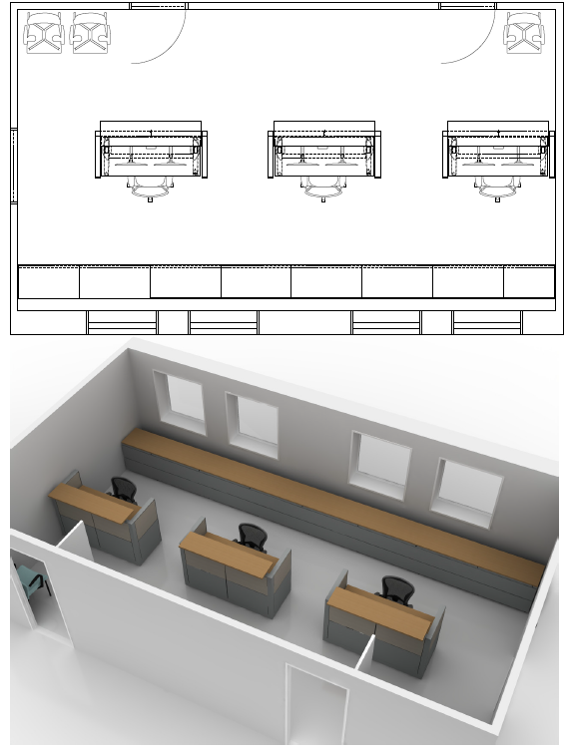

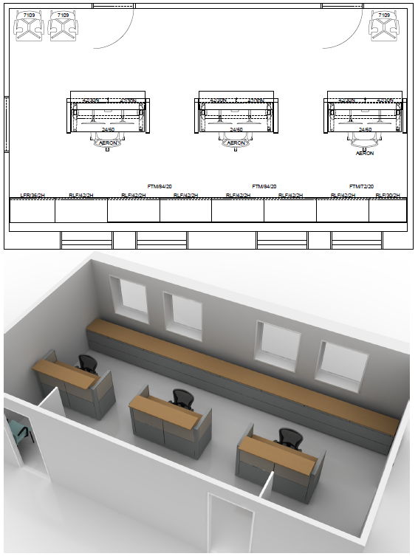

3 Workstations and Storage
MD2 Freestanding straight workstation and transaction counter, lockable undersurface storage. Lockable storage where appropriate. Storage base to integrate one leg of height adjustable surface. Standard finishes.
HAW3 Electric height adjustable base, C-leg, with integrated cord management. HPL top with intuitive power switch. Standard finishes.
CS2 Clamp mounted dual monitor arm with integrated cord management. Single post must be able to add or remove arms in place. Silver (Basis of Design: Humanscale MFlex).
GC2 Guest chairs with arms (3), cushioned, fully upholstered Standard finishes.
LF1 2 drawer lateral file cabinets at various sizes (please see sizes in renderings above). Filing front to back. Standard finishes. Laminate top to go on top of all lateral files. Cabinets are required to be lockable.

Ergonomic Task Chairs
TS2 Fully Adjustable high back Ergonomic task chairs (5) with 5 caster swivel base and casters for carpet or hard floors. (Basis of Design: Herman Miller Aeron) Standard finishes.

8.0 SERVICES

SERVICE REQUIRED IS DETAILED IN SV1.

Design Contract Tasks/Requirements
- The contractor shall attend a minimum of three (3) in-person meetings at the VA Battle Creek Medical Center to review final award with VA Interior Designer and End Users and to make necessary revisions.
- During first meeting the contractor shall provide the Interior Designer with the Auto-Cad drawings to [1/4” – 1/8”] scale drawings showing layouts of awarded product.
- The contractor shall allow for three (3) revisions per line item included in design services including updating Auto-Cad Drawings and PDFs as request by VA Interior Designer.
- The contractor shall be responsible for taking and applying accurate field measurements to ordered product for verification of correct sizing. Auto-Cad drawings may not be accurate finished dimensions and may not be used in place of field measurements. The Vendor shall be liable for any incorrect field measurements leading to incorrect product order.

- The contractor shall be responsible for providing all sample materials for awarded product (2-Day Delivery) as requested by VA Interior Designer.
- The product must not be placed into production without clearance from the VA POC.

- The contractor shall provide final, clean [1/4” – 1/8”] scaled drawings of product layout for sign-off prior to scheduling manufacturing.
- The contractor shall track manufacturing schedule and notify VA Interior Designer with updates of estimated completion date by email.
- The contractor shall attend a post-installation meeting to assess, address, and document any punch-list items and shall submit to the VA Interior Designer a remediation plan within 5 business days.
- The contractor shall provide 30 days free storage.
The Government maintains the option to modify the normal work week, days and hours, as necessary for the accomplishment of VHA mission.

9.0 WORK REQUIRED BY OTHERS

All work required by other trades shall be identified under this section by the Bidder.

