William S. Middleton Memorial VA Medical Center
2500 Overlook Terrace
Madison, WI 53705

Project: Modular Check in Desks

VA Point of Contact: Tracie Dunham, Interior Designer

Requisition # 607-23-3-081-0231

STATEMENT OF WORK
1.0 GENERAL SCOPE
The Veterans Health Administration (VHA) has a requirement for replacement of built-in check in desks with modular desks at the Rockford, IL CBOC in Rockford IL that meet the VHA IDIQ specifications and high-quality threshold while integrating excellent environmental stewardship.
This requirement includes healthcare furniture, design, project management, professional installation, and maintenance/warranty services. Service required is detailed in Section 8.0 [SV1, SV4] is detailed in Section 8.0. Healthcare Furniture technical requirements per VHA Healthcare Furniture multiple award IDIQ. The Contracting Officer Representative (COR), is Roshandran Mahendran, roshandran.mahendran@va.gov and the primary point of contact is the interior designer, Tracie Dunham, tracie.dunham@va.gov
Healthcare furnishings include 3 locations for modular check in desks, and one consult cubicle.
The contractor shall provide all labor, materials, equipment, transportation, and supervision necessary to satisfy the needs of each ordering activity.
2.0 PERFORMANCE REQUIREMENTS
The contractor shall provide and be responsible for the technical assistance, development, and generation for final specifications.
The contractor will deliver the new furniture items to the Rockford CBOC VA Clinic. This furniture order will need to be coordinated with the tear out of the existing old millwork and the new flooring replacement, which will be done prior to the furniture install.
Duty hours will be normal business hours, 8:00 am – 4:00 pm, Monday through Friday. The Government recognized US holidays are: New Year’s Day, Martin Luther King, Jr. Day, Presidents Day, Memorial Day, Juneteenth, Independence Day, Labor Day, Columbus Day, Veterans Day, Thanksgiving Day, and Christmas Day. If the holiday falls on Sunday, it is observed on Monday.
The contractor shall:
Coordinate and provide project management of all products and services to manage, design, order, ship, deliver and install new furniture from the manufacturer until final acceptance by Tracie Dunham, the Interior Designer, Madison VA Point of Contact.

- Project installation/delivery to be coordinated with the demo of existing and new flooring install (completed by building owner)
- Only include products specified within the IDIQ.
- The awarded IDIQ partner shall not place any orders without prior consent by the VA interior designer. The awarded IDIQ partner shall not place any orders in advance of the required delivery date.
- Final order sign-off prior to manufacturer submittals must be given by the VA designer.
- Cancellation deadlines, and any penalties to the VA, must be clearly stated in your response with a valid manufacturer contact name for confirming this information with.
- Color renderings of all items with final finish selections must be furnished to the VA designer prior to ordering.
- Provide maintenance manuals for all products specified.
3.0 KICKOFF MEETING
The prime contractor(s) shall participate in a kickoff meeting within ten (10) days of task order issuance, either via teleconference or in person at Jesse Brown VA Medical Center. Time and date will be determined by VA Point of Contact.
4.0 SUBMISSION OF QUESTIONS
Questions: All questions must be received by XXXX, 2023. All questions submitted for this solicitation must be electronically sent to the Contracting Officer assigned to this project. Questions received after the stated date and time, may be addressed at the discretion of the Contracting Officer.

5.0 SUBMISSION OF QUOTATION

Quote Submission: The contractors shall submit complete emailed electronic copy portable document format (.pdf) or Microsoft Excel (.xls) format of:

Volume 1: (technical)
- complete manufacturer’s product specifications
- quantity of man hours for labor/installation
- project management plan
- product literature
- project staffing plan
- physical finish samples
- sustainability certification documents
- complete testing results / certificates
- mock-up samples (list any needed here)
- warranty.
- Self-certifying statement confirming ability to meet project deadlines
- Past performance examples with the VA

Volume 2: (pricing)
- price quote with separate line for labor/installation
- Bill of Materials with subtotals and tagged per CLIN/ floorplan
Submissions can be sent to the Contracting Officer in multiple emails to avoid computer system email size limitation. Quotes submitted by any other method will not be considered. All proprietary information shall be clearly marked. The use of hyperlinks in quotes is prohibited. Late quotes will not be accepted for evaluation. The contractor is responsible for confirming the Government’s receipt of the contractor’s quote.
Pricing must be within the established IDIQ Pricing.
6.0 EVALUATION CRITERIA
EVALUATION:
The Government will award a contract based on Comparative Analysis procedures. The following factors shall be used to evaluate offers:

Technical Capability—The Government will evaluate product solutions based on information furnished by the offeror or identified by the offer. The Government is not responsible for locating or obtaining any information not included or identified in the offer. The product (s) quoted is/are determined technically acceptable provided it meets the salient physical, functional or performance characteristic of the product (s) specified in this solicitation. Quotes shall be rated as Acceptable (A) or Unacceptable (U) based on the following:
- Did the Offeror provide a completed Price/Cost Schedule?
- Does the offeror provide solutions that offer the best value to the VA?
- Did the offeror provide all the supporting documents outlined in Volume 1?
- Do the offered products meet the salient characteristics as outlined in the Statement of Work?
Price/Best Value—The Government will evaluate technically acceptable offers by adding all line item prices—the Total of All CLINS will be that sum. The Government may use various price analysis techniques to make a price reasonableness/best value determination. Offers that do not meet the technical capability requirements of the Statement of Work shall not be selected regardless of price.
Options: The Government will evaluate offers for award purposes by adding the total price for all options to the total price for the basic requirement. The Government may determine that an offer is unacceptable if the option prices are significantly unbalanced. Evaluation of options shall not obligate the Government to exercise the Option(s).
Award Notification: A written notice of award or acceptance of offer, mailed or otherwise furnished to the successful offeror within the time for acceptance specified in the offer, shall result in a binding contract without further action by either party. Before the offer’s specified expiration time, the Government may accept an offer (or part of an offer), whether there are negotiations after its receipt, unless a written notice of withdrawal is received before award.
Important Notice: Offers must be both VISIBLE and VERIFIED by the Department of Veterans Center for Verification and Evaluation at the time of contract award. Failure to be both VERIFIED by CVE and VISIBLE on VetBiz at the time of contract award will result in the offeror’s quote being deemed non-compliant and not considered for award.

7.0 PRODUCT
General

All finished surfaces shall be free of scratches, mars, dents, or blemishes, and withstand staining, and exhibit to flaking, cracking, or loss or adhesion.

Furnishings shall have smooth finishes with no hazardous projections, sharp corners, or detail, which can be hazardous and cause personal injury or damage to clothing.

The following is being used as the basis of design. Provide samples of all finishes.

OFFICE FURNITURE

Quantity: 2
Description: Herman Miller, TU Metal Storage, Mobile BF
Rooms: Registration Desk102 (1), Consult Cubicle (1)
Basis of Design/Brand Name or Equal: Herman Miller TU
MTR Code: MSS2
Name Brand or Equal per paragraph 3
Salient Characteristics/Options:
GREENGUARD Certified
Box/Box/File metal mobile pedestal
20”D
¾ -extension roller slides on box drawer, Full-extension ball bearing on file drawer
Smooth paint on smooth steel, Keyed alike
Drawer divider in one box drawer, pencil tray in one box drawer, 2 file converters in file drawer.
Finish, cabinet: Soft White Metal Finish or equal (provide color samples per paragraph 2B).
Pull: W Pull

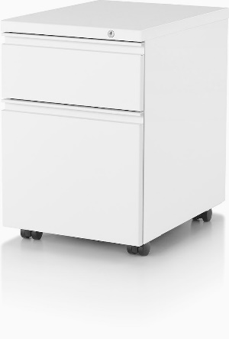

Quantity 13
MTR: TS1
Description: Task Chair
Rooms: Registration desk 102 (4); North Desk 222 (4); Consult Cubicle 225 (1).
South Desk 149 (4)
Basis of Design/Brand Name or Equal: Herman Miller, Mirra Name Brand or Equal per paragraph 3
Salient Characteristics/Options:
GREENGUARD certified
The chair shall be 93% recyclable
Mesh back, Mesh seat, Flexible seat depth
Adjustable arms, 5-leg base, carpet casters
The chair shall offer a fixed and adjustable flex front seat depth option
Adjustable seat shall have a range of 1-3/4”
The seat/back shall be constructed of a durable and breathable suspension material to allow airflow for thermal comfort.
Independent height-adjustable lumbar option with a 4-1/2” height range and a 1” depth adjustment.
Arm height adjustment range shall be 5-1/2”- from 6.0” to 11.5” from the seat.
Arm pad shall pivot a minimum of 20 degrees inward and 20 degrees outward.
350-pound seating capacity
Warranty: 12 year including parts & labor/ 3 shifts/24 Hr. Coverage
Finish, fabric: Slate Grey or similar mesh seat and back; latitude back: Slate Grey
Finish, frame: Graphite or similar plastic, aluminum and or steel
Arm Pad: Black
Casters: 2-1/2” caster, black yoke, hard floor or carpet
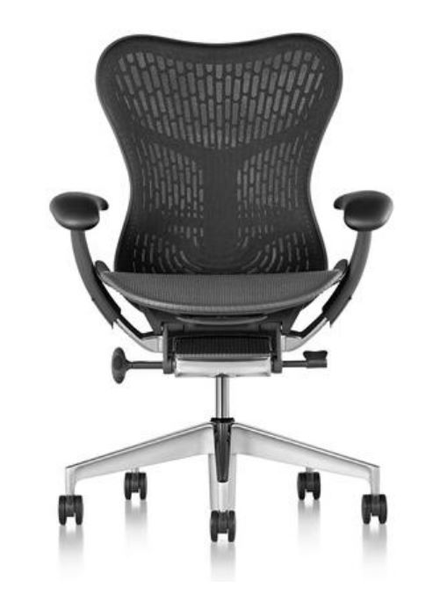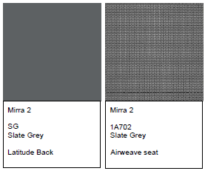

Quantity 1
MTR Code: HAW3
Description: Desk, Height Adjustable
Room: North Desk 222 (1) South Desk 149 (2)
Basis of Design/Brand Name or Equal: Herman Miller
Salient Characteristics/Options:
Nominal Surface Size 24x42
Electric height, extended range minimum 22” to 48"
Laminate worksurface, Thermoplastic Edge, C-Foot
12-year, 3-shift warranty covering all electrical sub-systems, operational and moving parts, and finishes, including both parts and labor.
Each Table Capable of lifting 200lbs minus the weight of the worksurface.
Complies with ANSI/BIFMA, Greenguard Certified, and FSC Certified
Finish, worksurface: Laminate Herman Miller, Soft White LU or equal (provide color samples per paragraph 2B).
Thermo Edge
Finish, base: Metallic Silver MS or equal (provide color samples per paragraph 2B).

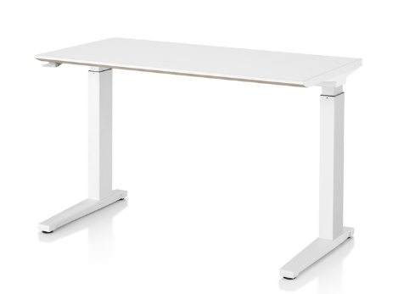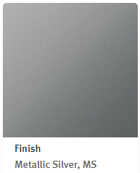

Quantity 10
MTR Code: HAW3
Description: Desk, Height Adjustable
Room: South Desk 149 (2); North Desk 222 (3); Information desk 102 (3)
Basis of Design/Brand Name or Equal: Herman Miller
Salient Characteristics/Options:
Nominal Surface Size 24x48
Electric height, extended range minimum 22” to 48"
Laminate worksurface, Thermoplastic Edge, C-Foot
12-year, 3-shift warranty covering all electrical sub-systems, operational and moving parts, and finishes, including both parts and labor.
Each Table Capable of lifting 200lbs minus the weight of the worksurface.
Complies with ANSI/BIFMA, Greenguard Certified, and FSC Certified
Finish, worksurface: Laminate Herman Miller, Soft White LU or equal (provide color samples per paragraph 2B).
Thermo Edge
Finish, base: Metallic Silver MS or equal (provide color samples per paragraph 2B).

Quantity 2
MTR Code: HAW3
Description: Desk, Height Adjustable
Room: Consult Cubicle 225 (1); Information Desk 102 (1)
Basis of Design/Brand Name or Equal: Herman Miller
Salient Characteristics/Options:
Nominal Surface Size 24x60
Electric height, extended range minimum 22” to 48"
Laminate worksurface, Thermoplastic Edge, C-Foot
12-year, 3-shift warranty covering all electrical sub-systems, operational and moving parts, and finishes, including both parts and labor.
Each Table Capable of lifting 200lbs minus the weight of the worksurface.
Complies with ANSI/BIFMA, Greenguard Certified, and FSC Certified
Finish, worksurface: Laminate Herman Miller, Soft White LU or equal (provide color samples per paragraph 2B).
Thermo Edge
Finish, base: Metallic Silver MS or equal (provide color samples per paragraph 2B).

Quantity 13
MTR Code: HAW3
Description: Power Logic Mini Receptacles
Room: Consult (1); South Desk 149 (4); Information Desk 102 (4); North Desk 222 (4)
Basis of Design/Brand Name or Equal: Herman Miller, Power Logic Mini Simplex Receptacles
Name Brand or Equal per paragraph 3
Salient Characteristics/Options:
Receptacles, 1 Power USB A/C Combo
12-year, 3-shift warranty covering all electrical sub-systems, operational and moving parts, and finishes, including both parts and labor.
Surface Clamp
Complies with ANSI/BIFMA, Greenguard Certified, and FSC Certified
Warranty: 5 yrs
Finish: Color: White or equal (provide color samples per paragraph 2B).

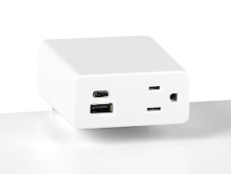

Quantity 13
MTR Code: CS2
Description: Dual Monitor Arms
Room: Registration Desk 102 (4), North Desk 222 (4), Consult Cubicle 225 (1), South Desk 149 (4)
Basis of Design/Brand Name or Equal: Herman Miller, Lima Monitor Arms
Name Brand or Equal per paragraph 3
Salient Characteristics/Options:
Tool-less installation (with the exception of attaching VESA plate to monitor)
8” height adjustment with Push button Technology, 18” focal adjustment
Tilt range: 80 degrees rearward; 10 degrees forward
Portrait or landscape option
Cable Management
12-year, 3-shift warranty covering all electrical sub-systems, operational and moving parts, and finishes, including both parts and labor.
Surface Clamp
Complies with ANSI/BIFMA, Greenguard Certified, and FSC Certified
Finish: Black or equal (provide color samples per paragraph 2B).

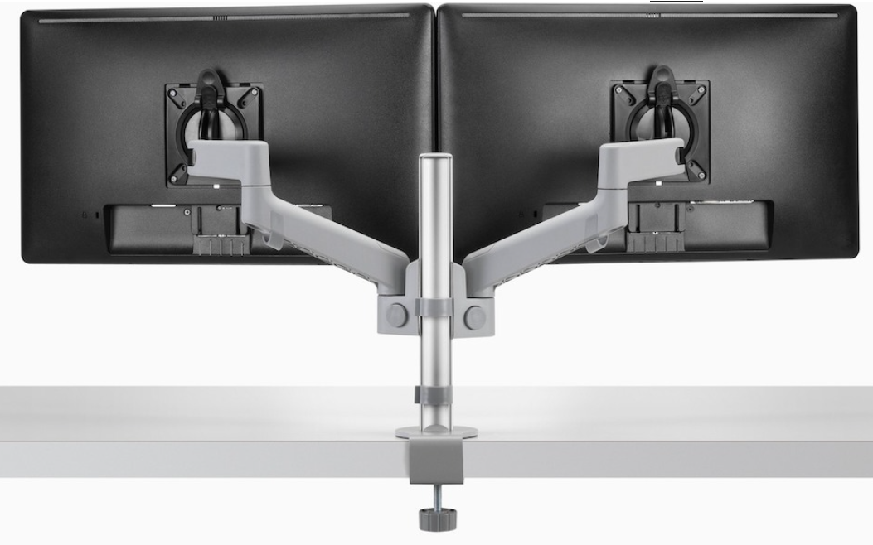

Quantity 1
MTR Code: MSF1
Description: Herman Miller, Ethospace System
Room: REGISTRATION DESK 102 (See Specs and Floorplan for all details)
Basis of Design/Brand Name or Equal: Herman Miller, Ethospace System
Furniture Item: Modular System Furniture / Teamwork Areas
Name Brand or Equal per paragraph 3
Salient Characteristics:
12-year, 3-shift warranty - including both parts and labor.
Greenguard Certified, FSC Certified, Indoor Advantage Gold Rating; Over 50% Recyclable
Complies with ANSI/BIFMA; Healthier Hospitals Compliant
38” H Panels
Qty: 1, 54”h x 24”w divider panel
Square Edge Transaction Surface, rectangular end, 8.9” d; overhand on outside to allow sit to stand desks; Finish: Solid Surface, Corian, color: Glacier White or equal.
Qty: 3, Ht. Adj. Desk; extended ht.; size: 24” x 48”
Qty: 1, Ht. Adj. Desk, extended ht.; size: 24” x 60”
Qty: 1, Fixed ADA corner worksurface
38” H Panels; Including Baseline Harness, 4-Circ
Qty: 2 Outlet Receptacles per workstation, (1-A & 1-B Circuit)
Power entry/Direct Connect
Finish, Ethospace Exterior Durawrap panels: Medium Matte Walnut Durawrap or similar.
Finish, Ethospace Frame: Metal Soft White or similar.
Finish, Ethospace Interior Wall Panels: 2 bottom rows Painted Soft White below with 16”h tackable fabric (Strands, Khaki) above or similar.

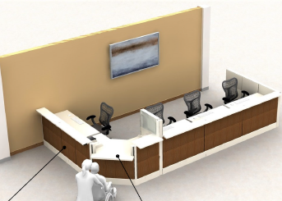

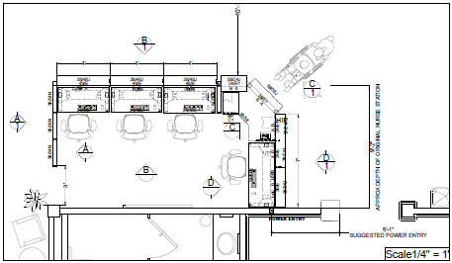

Quantity 1
MTR Code: MSF1
Description: Herman Miller, Ethospace System
Room: CONSULT CUBICLE 225 (See Specs and Floorplan for all details)
Basis of Design/Brand Name or Equal: Herman Miller, Ethospace System
Furniture Item: Modular System Furniture / Teamwork Areas
Name Brand or Equal per paragraph 3
Salient Characteristics/Options:
12-year, 3-shift warranty - including both parts and labor.
Greenguard Certified, FSC Certified, Indoor Advantage Gold Rating; Over 50% Recyclable
Complies with ANSI/BIFMA; Healthier Hospitals Compliant
38” H Panels
Qty: 1; 70”h x 36” w Privacy Door w/ Translucent plastic
Qty: 1, Ht. Adj. Desk; extended ht.; size: 24” x 60”
70” H Panels; Including Baseline Harness, 4-Circ Power entry/Direct Connect
Finish, Ethospace Exterior panels: Metal Soft White or similar.
Finish, Ethospace Frame: Metal Soft White or similar.
Finish, Ethospace Interior Wall Panels: Painted Soft White on bottom row or similar
Finish, Ethospace Interior Wall Panels: Tackable fabric (Strands, Khaki) above or similar.
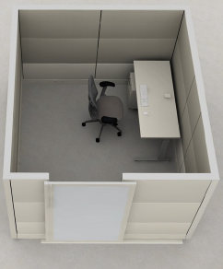

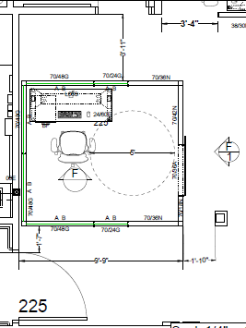

Quantity 1
MTR Code: MSF1
Description: Herman Miller, Ethospace System
Room: 1 NORTH DESK 222 (See Specs and Floorplan for all details)
Basis of Design/Brand Name or Equal: Herman Miller, Ethospace System
Furniture Item: Modular System Furniture / Teamwork Areas
Salient Characteristics/Options:
12-year, 3-shift warranty - including both parts and labor.
Greenguard Certified, FSC Certified, Indoor Advantage Gold Rating; Over 50% Recyclable
Complies with ANSI/BIFMA; Healthier Hospitals Compliant
38” H Panels
Qty: 3, 54”h x 24”w divider panel
Square Edge Transaction Surface, rectangular end, 8.9” d; overhand on outside to allow sit to stand desks; Finish: Solid Surface, Corian, color: Glacier White or equal.
Qty: 3, Ht. Adj. Desk; extended ht.; size: 24” x 48”
Qty: 1, Ht. Adj. Desk, extended ht.; size: 24” x 42”
Qty: 1, Fixed ADA 36” w worksurface
38” H Panels; Including Baseline Harness, 4-Circ
Qty: 2 Outlet Receptacles per workstation, (1-A & 1-B Circuit)
Power entry/Direct Connect
Finish, Ethospace Exterior Durawrap panels: Medium Matte Walnut Durawrap or similar.
Finish, Ethospace Frame: Metal Soft White or similar.
Finish, Ethospace Interior Wall Panels: Painted Soft White below with 16”h tackable fabric (Strands, Khaki) above or similar.

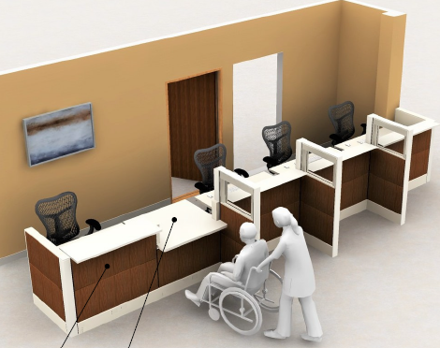

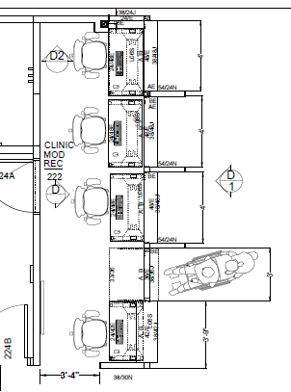

Quantity 1
MTR Code: MSF1
Description: Herman Miller, Ethospace System
Room: 1 SOUTH DESK 149 (See Specs and Floorplan for all details)
Basis of Design/Brand Name or Equal: Herman Miller, Ethospace System
Furniture Item: Modular System Furniture / Teamwork Areas
Salient Characteristics/Options:
12-year, 3-shift warranty - including both parts and labor.
Greenguard Certified, FSC Certified, Indoor Advantage Gold Rating; Over 50% Recyclable
Complies with ANSI/BIFMA; Healthier Hospitals Compliant
38” H Panels
Qty: 3, 54”h x 24”w divider panel
Square Edge Transaction Surface, rectangular end, 8.9” d; overhand on outside to allow sit to stand desks; Finish: Solid Surface, Corian, color: Glacier White or equal.
Qty: 2, Ht. Adj. Desk; extended ht.; size: 24” x 48”
Qty: 2, Ht. Adj. Desk; extended ht.; size: 24” x 42”
Qty: 1, Fixed ADA worksurface, 36”w
38” H Panels; Including Baseline Harness, 4-Circ
Qty: 2 Outlet Receptacles per workstation, (1-A & 1-B Circuit)
Power entry/Direct Connect
Finish, Ethospace Exterior Durawrap panels: Medium Matte Walnut Durawrap or similar.
Finish, Ethospace Frame: Metal Soft White or similar.
Finish, Ethospace Interior Wall Panels: Painted Soft White below with 16”h tackable fabric (Strands, Khaki) above or similar.

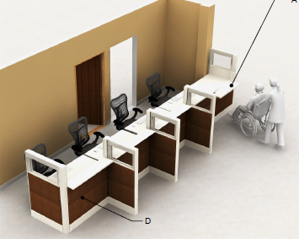

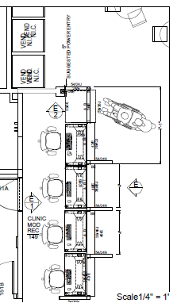

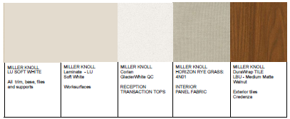

8.0 SERVICES

Service required is detailed in SV1 word document- Installation and Reconfiguration Services iterated below.

1.0 General Scope:
The Veterans Health Administration (VHA) has a recurring requirement for healthcare furniture for the Medical Centers, the Community-Based Outpatient Clinics (CBOCs), the Vet Centers, and other outlying clinics and offices throughout the United States and its territories. This is an effort by VHA to streamline the acquisition process and obtain further discounted commercial pricing.

This requirement includes healthcare furniture, design, project management, furniture removal, professional installation and maintenance/warranty services. A Contracting Officer Representative (COR) may be assigned at the IDIQ ordering level.

The contractor shall provide all labor, materials, equipment, transportation, and supervision necessary to satisfy the needs of each ordering activity.

2.0 Delivery: All orders shall be delivered Free On-Board (FOB) destination to the delivery addresses listed in the individual orders placed against the IDIQ. Specific delivery/shipping information shall be determined at the individual order level.

6.0 General Requirements for Services: The dates and times for delivery, receipt and installation of furniture will be established by individual orders. Delivery, receiving and installation of furniture will be determined on the individual orders and may occur outside of normal duty hours to not interfere with patient care in accordance with the IDIQ order.

- When the Contractor requests to deliver, receive and/or install furniture outside normal duty hours. When these instances occur, a written request shall be submitted to the VA Contracting Officer’s Representative (COR) for authorization of the individual orders of this type. Written approval from the VA COR must be received before proceeding with the work. The request shall be submitted at least (5) five business days prior to the proposed performance of work, and it shall indicate the day(s), time, the amount of work, and the reason why performance is necessary outside normal duty hours.
- The Contractor shall be made aware of and must comply with local security policies and procedures in the task order. The Contractor will comply to these standards during all site visits on Governmental property. Contractor shall contact the VA COR at least 14 days prior to work start date to ensure compliance to any local security policies.
- The Contractor personnel shall present a professional appearance and shall have a uniform or some method of identifying them as an employee of the contractor. A VA badge will be provided and must be worn above the waist and be always visible while on government property.
- The Contractor shall ensure policies and procedures are established that protect the safety and welfare of customers, employees, and the community to minimize or eliminate safety or environmental risks.
- The Contractor shall be knowledgeable of and shall comply with all applicable federal, state, and local laws, Building Codes, Life Safety Codes, Occupational Health and Safety Administration (OSHA), ADA/ADAG, permits, VA design standards (www.cfm.va.gov/til/dguide.asp), and instructions required for the performance of the duties in the Statement of Work (SOW).
- The Contractor is responsible for ensuring that its firm and staff maintain any generally required professional certification, accreditation, license, bond, and proficiency relative to their area of expertise. The Contractor shall retain documentation of such records. The Government will not pay for expenses to meet this requirement.
- The Contractor is responsible for ensuring staff are trained and certified for planning and installing product to maintain the integrity of the manufacturer’s warranty.

SV1 – Furniture, Design, and Installation Support Services

Contract Tasks/Requirements

- Contractor may be required to provide basic design services and layout for commodities purchased. All designs of furniture layouts, including original designs and any subsequent redesigns, must be accomplished by a qualified professional Interior Designer with either a four (4) year Interior Design degree from an accredited school by the Council for Interior Design Accreditation (CIDA/FIDER), or 5 years of experience, and one year experience using contractor’s software similar to that proposed for this contract.

- Contractor is required to provide installation drawings for furniture purchased.

- Contractor shall place all orders, track orders, schedule deliveries and coordinate trucks with the manufacturer for manufacturing and delivery according to VA project schedule.

- Contractor shall be responsible for all field measurements whether in existing spaces or new construction. Contractor shall not rely on AutoCAD drawings for final measurements.

- Contractor shall perform installation services per task order SOW.

- Contractor must have a project manager/lead installer based on project size. Project manager/lead installer must have a minimum of 2 years of experience performing installation services in healthcare facilities.
- Contractor may be required to remove and/or relocate existing VA furnishings in coordination with VA Logistic Management Service and Interior Designer per the task order SOW.

- Contractor may or may not be required to complete services outside of normal duty hours per the SOW.

- Contractor shall be familiar with VA campuses and various VA Outpatient Clinics, regulations, loading dock locations and hours of operations.

- Contractor must provide Proof of Insurance.

- Contractor shall provide 30 Days Free Storage once the complete bill of materials has been received at a conditioned facility that meets all building requirements including but not limited to the sprinkler, security, safety, temperature and environmental controls – as not to void furniture warranties.

- Contractor must notify VA of the specific location of any or all stored furniture.

- Contractor shall provide all necessary materials, equipment, labor, supervision, and Management to: (A) coordinate delivery: (B) load and unload; (C) place/install items in designated rooms/locations; (D) assemble items as required; (E) secure as designated; and (F) properly dispose of all associated packing/crating materials outside the VA premises.

- VA COR: to be specified at delivery/task order level.

Protection of Property

- The Contractor shall perform an inspection of the buildings and grounds with the COR prior to commencing work. Contractor shall protect all items from damage. The Contractor shall take precaution against damage to the buildings, grounds and furnishings. The Contractor shall repair or replace any items related to buildings or grounds damaged accidentally, or on purpose due to actions by the Contractor, utilizing materials of the same quality, size, grade and color, to match existing work.

- To ensure that the contractor shall be able to repair or replace any items, components, on the buildings or grounds damaged due to negligence and/or actions taken by the Contractor. The Contractor shall communicate with the COR to resolve all repairs beyond simple surface cleaning. Concurrence of the COR is required before the Contractor may perform any significant repair work. In all cases, repairs shall utilize materials of the same quality, size, texture, grade and color to match adjacent existing work.

- The Contractor shall be responsible for the security of the areas in which the work is being always performed prior to completion. The Contractor shall maintain accountability and control of any keys provided and shall return them to the COR upon completion of the work.

- Contractor shall provide floor protection while working in all VA facilities. All material handling equipment shall have rubber wheels.

Delivery

- Contractor shall contact the COR at least 14 business days prior to the start of work/shipping to ensure that the building is ready for install.

- In the event there is a delay in delivery, Contractor must notify the assigned VA COR immediately in writing, preferably via email.

- Contractor shall provide the COR with scheduled date and time that the delivery truck will be arriving at least 24 hours minimum in advance.

- Contractor must ensure that the driver of the delivery vehicle has copies of the Bill of Materials/delivery orders and shall not attempt to deliver any items before the scheduled delivery date.

Receive and Unload

- If the Contractor is unable to complete the assembly and placement of all unloaded items before the end of the workday, the Contractor will be responsible for moving these items to a secure location, until the next available work day. The Contractor will be responsible for moving the items from the overnight storage site to its designated position in the building.

- The Contractor shall verify and inspect all items. All deficiencies (damage/overage/shortage) shall be brought to the attention of the assigned VA CO in writing, preferably via email, immediately upon identification.

- The Contractor shall store damaged items in the location designated by the COR. The Contractor shall maintain a complete file of all documents relating to each discrepancy and copies of all Discrepancy Reports shall be forwarded to the COR daily.

- Contractor shall repair or coordinate with the COR for replacement of damaged, defective, or missing items.

Assembly and final acceptance

- Contractor shall be responsible for all safety and security guidelines within the area in which work is being performed, to include securing any contractor-owned tools or equipment, and any on-site storage being utilized.

- The contractor shall install all items in accordance with each requirement statement and basic component floorplan, panel plan and electrical plan, designed and provided by the contractor with each task order.

- Contractor shall uncrate all items received and perform all required assembly in accordance with the manufacturers’ instructions.

- Contractor shall prevent its personnel from entering any area other than the designated work area.

- The Contractor shall maintain a means of egress within all designated work areas to comply with fire codes.

- Contractor shall inspect to ensure that the furniture is free of surface dirt, clean and polished, free of defects, and that the installation is complete and ready for use.

- The Contractor shall do a final walkthrough with COR and provide a punch list before releasing crew for the day.

Jobsite Cleanliness

- Contractor will be responsible for the removal and disposal of all trash/debris connected with uncrating and assembling all items installed under this contract.

- Final Acceptance by the Government will not occur until all installed items have been wiped cleaned and debris/dust connected with installation is removed from the VA site.

- Recyclable cardboard products shall be disposed of in accordance with applicable statutes, in respective containers. The contractor is responsible for providing trash containers at an offsite facility.

- Packing materials will not be stored in the buildings for any period exceeding 24 hours.

- The Contractor shall ensure its personnel eat, drink, or smoke only in designated areas.

- Personal trash (food wrappers, drink containers, etc.,) shall be removed from the site daily by the Contractor.

Warranty Items

- The warranty of an item is to start on the date of acceptance of the products/services by the Government VA COR.

- The Contractor agrees to furnish, without cost to the Government, replacement of all parts and material which are found to be defective during the warranty period. The cost of installation and travel of replacement material and parts shall be borne by the Contractor.

SV2 – Installation and Reconfiguration Services

Contract Tasks/Requirements

- Contractor to provide installation and reconfiguration services per the Statement of Work. Furniture installations and reconfigurations include, but are not limited to the following: free-standing, panel-hung systems, and modular furniture disassembly, relocations, reassembly, and configurations, the disassembly and reassembly of shelving, and special items such as rotary cabinets and mobile rolling file cabinet systems. All furniture installations and reconfigurations require the COR’s approval of a plan provided by the Contractor.

- Contractor will be required to move and transport products between multiple sites within the applicable Healthcare System. Moving activities include but are not limited to moving miscellaneous free-standing furniture items, file record boxes, employee property such as boxed files, records and computers, equipment, filing cabinets of various types and sizes of pallets to a different locations, delivering and picking up empty moving boxes, minor furniture repair and disposal of designated items such as removal of trash from work sites. If movement of PHI and PII (records and computer equipment) is required contractor must have a Business Associate Agreement (BAA).

- Contractor to provide storage, inventorying, stocking and distribution services per the SOW. Storage and Stocking Services include but not limited to maintaining an inventory of VA furnishings for redistribution within the applicable Healthcare System per the SOW and providing ongoing storage at an approved and conditioned storage facility per SOW.

- Contractor to provide hauling, excessing and recycling services of VA furnishings in coordination with the VA COR per SOW.

- The Contractor shall provide final move, installation, configuration plans 5-14 days prior per the SOW.

- The Contractor may be required to provide basic furniture design layout AutoCAD and/or PDF drawings of final furniture layouts as directed by the VA COR.

- Contractor shall collaborate with VA COR to coordinate compliance with any in-house service that may be affected by installation such as IT, Housekeeping, Facilities, and In-House Construction Teams. Specific, required meetings will be identified at the order level.

- Contractor shall be solely responsible for all field measurements and may not rely on AutoCAD files or drawings for final measurements.

- The Contractor shall designate an on-site project manager/lead installer. An on-site project manager/lead installer will require a cell phone or other means of communication coordinate each moving service activity with the VA COR. The project manager/lead installer will be responsible for oversight for all aspects of the project.

- The Contractor shall provide sufficient and consistent personnel/crews based on workload as required accomplishing assigned tasks in the time frame stated on task order. Requests for additional personnel/crews will be made a minimum of five calendar days in advance of the moving service activity.

- The Contractor shall provide, operate, manage and maintain a trained, uniformed Moving Services crew.

- The Contractor shall ensure that crew members have the technical capability to assemble and disassemble all types of furniture and specialized equipment before performing such tasks.

- The Contractor’s personnel shall have the ability to: meet and deal with the general public; ability to read, understand and apply printed rules, detailed orders, instructions and furniture drawing layouts. The contractor’s personnel shall also have familiarity with a variety of commercial furniture product disassembly and assembly parts and components; and be able to physically perform the functions required in the performance of their assigned duties.

Protection of Property

- The Contractor shall perform an inspection of the buildings and grounds with the COR prior to commencing work. Contractor shall protect all items from damage. The Contractor shall take precaution against damage to the buildings, grounds and furnishings. The Contractor shall repair or replace any items related to buildings or grounds damaged accidentally, or on purpose due to actions by the Contractor, utilizing materials of the same quality, size, grade and color, to match existing work.

- To ensure that the contractor shall be able to repair or replace any items, components, on the buildings or grounds damaged due to negligence and/or actions taken by the Contractor. The Contractor shall communicate with the COR to resolve all repairs beyond simple surface cleaning. Concurrence of the COR is required before the Contractor may perform any significant repair work. In all cases, repairs shall utilize materials of the same quality, size, texture, grade and color to match adjacent existing work.

- The Contractor shall be responsible for the security of the areas in which the work is being always performed prior to completion. The Contractor shall maintain accountability and control of any keys provided and shall return them to the COR upon completion of the work.

- Contractor shall provide floor protection while working in all VA facilities. All material handling equipment shall have rubber wheels.

Assembly and final acceptance

- Contractor shall be responsible for following all safety and security guidelines within the area in which work is being performed, to include securing any contractor-owned tools or equipment, and any on-site storage being utilized.

- The Contractor shall maintain a means of egress within all designated work areas to comply with fire codes.

- Contractor shall inspect to ensure that the furniture is free of surface dirt, clean and polished, free of defects, and that the installation is complete and ready for use.

- The Contractor shall do a final walkthrough with COR. The Contractor will correct deficiencies at no additional cost to the government.

Contractor Furnished Materials and Equipment

- On-site supervisor must be available via telephone while working on-site.

- Specialty moving materials, tools, and supplies, including but not limited to padding, packing, crating, dollies/hand trucks, and any other type of equipment commonly used for moving services activities, as required for the safe transportation of the property.

- Boxes necessary to move and pack as required in individual order.

- Vehicles/Trucks necessary for meeting the transportation and delivery needs of the individual order.

Jobsite Cleanliness

a. Contractor will be responsible for the removal and disposal of all trash/debris connected with uncrating and assembling all items installed under this contract.

b. Final Acceptance by the Government will not occur until all installed items have been wiped cleaned and debris/dust connected with installation is removed from the VA site.

c. Recyclable cardboard products shall be disposed of in accordance with applicable statutes, in respective containers. The contractor is responsible for providing trash containers at an offsite facility.

d. Packing materials will not be stored in the buildings for any period exceeding 24 hours.

e. The Contractor shall ensure its personnel eat, drink, or smoke only in designated areas.

f. Personal trash (food wrappers, drink containers, etc.,) shall be removed from the site daily by the Contractor

SV3 – Industrial Design Services

Contract Tasks/Requirements

- As part of the request for design service quotes the contractor will provide a quote on a specifically requested scope of work/Project and provide a firm-fixed price.

- Contractor to provide end-user programming services, space planning, product specifications, and attend in-person end-user meetings with VA COR.

- Contractor to develop and provide detailed specifications, conduct product research and assemble materials/finishes as approved by VA COR. Contractor to provide finished specification binder with cut sheets and material samples to the VA per the SOW.

- Contractor to provide design services such as space planning, schematic design, specifications, finish boards, 2D/3D Rendered models, construction drawings, installation layouts in AutoCAD, Sketch Up, Revit, and Adobe Creative Suite Programs.

- Contractor to provide expert support in Environmental Product specifications, tracking, and documentation building to obtain LEED Credits for ongoing projects as needed.

- Contractor to provide Professional Project Management Services including field support, design, move and installation coordination and management of small to large scale projects per the SOW.

- Contractor shall act in collaboration with VA COR and multi-disciplinary services such as IT, Housekeeping, Facilities, and In-House Construction Teams.

- Contractor will provide a quote on a specifically requested scope of work/project and provide a firm-fixed price.

- The contractor shall define and furnish the necessary hardware, software, and all other equipment necessary to accomplish design tasks. Standard equipment in addition to the hardware and software shall include but not limited to reproduction machines, plotters, paper, pencils/pens/markers/highlighters, fax machines, email, and appropriate workspace.

- The contractor shall be responsible for participating with the COR during the collection of information relevant to the design/redesign of a space. Examples could include personnel interviews, questionnaires and walk-through inspections of the facility, as well as the existing furniture database (if available). Access to an existing furniture database will be determined at the task order level, as needed.

- Services shall include site evaluation to ensure proper fit of the furniture within the given space and that all structural and other anomalies are considered.

- The contractor is responsible for notifying the VA COR of all power requirements regarding location of communication, LAN and power junction boxes, with the expectation that the user will be responsible for providing and locating those junction boxes within 4'- 0" of the ceiling penetration of the power pole location provided by the contractor and within the required distance on the wall for J-boxes.

- If electrical power poles are needed in the design, the design shall ensure that power poles do not protrude into main walkways.

- The design shall ensure that all outlets included in the design are accessible to the user, free and clear of obstacles.

- The design shall not allow more than four cubicles to be served by a single circuit.

- The design shall ensure that no existing wall outlets or thermostats are covered or concealed by panels or other systems furniture components.

- The contractor shall utilize any existing government product to its maximum as applicable when the project includes add-on parts to existing systems furniture.

- All designs of furniture layouts, including original designs and any subsequent redesigns, must be accomplished by a qualified professional Interior Designer with either a four (4) year Interior Design degree from an accredited school by the Council for Interior Design Accreditation (CIDA/FIDER), or 5 years’ experience, and one year experience using contractor’s software similar to that proposed for this contract.

- The contractor shall meet with the VA COR to review the installation drawings prior to submission of a final price quote. Specific, required coordination will be identified at the order level.

- The contractor shall provide additional drawings of furniture layouts, if requested by VA organizations in an unlocked electronically transmitted AutoCAD drawing set complete with any attached layers in both .dwg and .pdf formats unless otherwise specified in the contract.

- The hardware/software utilized by the contractor shall perform computerized inventory, computer aided design, automated take-off function, and report generation for all product purchased. The software for this contract shall be compatible software for AutoCAD. The software shall be fully compatible with Microsoft Windows, the most current version.

- Design service shall include an initial complete design with up to three additional revisions prior to final approval. Designs of each location shall include a Panel and Hardware Layout sheet for system and modular furniture: to include all finish colors and fabrics, panel widths (30", 36", 42", etc.), in 1/4" = 1'0" scale, in addition to display hardware, keys and locksets shall be included.

- Design sheet layouts of each location shall include a Furniture Power Distribution sheet in 1/4" = 1'0" scale to include: the location of all powered panels, powered components, receptacles, communication ports, power poles, powered raceways, base electrical feeds and building connection points.

- Designs of each location shall include a 3D drawing and/or elevations for clear understanding of objects that cannot be seen in floor plan view.

- Design/redesign timelines shall be expected:

aa. Design sheet layouts for all phases of design (initial, revisions and final) of 1-10 workstations shall be received within 3 business days unless otherwise directed in the contract.

bb. Design sheet layouts for all phases of design (initial, revisions and final) of 11-25 workstations shall be received within 5 business days unless otherwise directed in the contract.

cc. Design sheet layouts for all phases of design (initial, revisions and final) of 26-50 workstations shall be received within 7 business days unless otherwise directed in the contract.

dd. Design sheet layouts for all phases of design (initial, revisions and final) of 51-100 workstations shall be received within 10 business days unless otherwise directed in the contract.

ee. Design sheet layouts for all phases of design (initial, revisions and final) of 101-200 workstations shall be received within 15 business days unless otherwise directed in the contract.

ff. Design sheet layouts for all phases of design (initial, revisions and final) of 200+ workstations shall be received within 20 business days unless otherwise directed in the contract.

gg. Within five (5) business days after the final design has been accepted by the requesting organization, a bill of materials detailing all inventory, and all plans including basic floor plan, moveable wall, panel and electrical layouts will be provided to the VA COR for the project.

hh. Drawing changes required to a layout due to contractor errors or omissions shall be the responsibility of the contractor and the corrected drawing and bill of materials shall be delivered to the government within three (3) calendar days of the request.

ii. Contractor shall make the government aware of any discrepancies to existing conditions not previously identified, immediately to the assigned VA COR in writing, preferably via email.

Project Manager (PM) Requirements

- The Contractor PM shall be responsible for the performance of all the work the associated with the SOW issued with the individual task orders. The Contractor shall additionally, provided an alternate PM and the name of the primary and alternate who shall act for the contractor PM when the manager is absent shall be designated in writing to the COR.

- Communication with VA COR as pertaining to Requests for Information (RFIs), updates, design changes, Quality Control concerns notifications and installation scheduling in writing by email in addition to any phone conferences or in-person meetings.

- PM shall schedule arrival of the product and installation date.

- PM shall perform an on-site review of space and installation plans at least 5 days in advance with VA Point of Contact (POC), COR or Interior Designer.

- PM shall perform on-site visit and assess area for any encumbrances (loading dock, the path of travel, electrical/data need locations, etc.) that would be a potential delay to the project.

- PM shall be on-site during installation to answer any questions regarding product installation or space/area.

- PM shall perform on-site walk-through and punch list after installation with Lead Installer and VA POC, COR or Interior Designer.

SV4 –Project Management Turnkey Services with Furniture

Contract Tasks/Requirements

a. Based on provided furniture specifications for the individual order, the contractor shall provide a separate, typed document that matches the VA line item: including unit price and total price per provided quantity. Products or services that include multiple parts shall be listed within each line item and only the totals for the whole unit and total price per quantity provided will be provided. No additional line items will be added.

- Package to include PDFs of detailed and dimensioned: Plan, 2-D and 3-D drawings of each workstation (and/or) products with multiple parts list to represent exactly what is being included in the bid and to determine accuracy.

- Package to include a cut sheet with product detail for any alternate products.

- Package to list Labor/Services on a separate line item(s) than the product line items.

- Contractor shall be responsible for ordering, tracking and installing all specified items, managing and coordinating all deliveries for the installation schedule as approved by the VA COR.

Design Contract Tasks/Requirements

- As part of the request for design service quotes the contractor will provide a quote on a specifically requested scope of work/Project and provide a firm-fixed price.

- Contractor to provide end-user programming services, space planning, product specifications, and attend in-person end-user meetings with VA COR.

- Contractor to develop detailed specifications, conduct product research and assemble materials/finishes as approved by VA COR. Contractor to provide finished specification binder with cut sheets and material samples to the VA per the Statement of Work.

- Contractor to provide design services such as space planning, schematic design, specifications, finish boards, 2D/3D Rendered models, construction drawings, installation layouts in AutoCAD, Sketch Up, Revit, and Adobe Creative Suite Programs.

- Contractor shall comply with all Environmental Product specifications, tracking, and documentation building to obtain Leadership in Energy and Environmental Design (LEED) Credits for ongoing projects as needed.

- Contractor to provide Professional Project Management Services including field support, design, move and installation coordination and management from small to large scale projects per the SOW.

- Contractor shall act in collaboration with VA COR and multi-disciplinary services such as IT, Housekeeping, Facilities, and In-House Construction Teams.

- The contractor shall define and furnish the necessary hardware, software, and all other equipment necessary to accomplish design tasks. Standard equipment in addition to the hardware and software shall include but not limited to reproduction machines, plotters, paper, pencils/pens/markers/highlighters, fax machines, email, and office furniture.

- The contractor shall be responsible for the collection of information relevant to the design/redesign of a space. Examples could include personnel interviews, questionnaires and walk-through inspections of the facility, as well as the existing furniture database (if available).

- Services shall include site evaluation to ensure proper fit of the furniture within the given space and that all structural and other anomalies are considered.

- The contractor is responsible for notifying the COR/Government Project Manager of all power requirements regarding location of communication, LAN and power junction boxes, with the expectation that the user will be responsible for providing and locating those junction boxes within 4'-0" of the ceiling penetration of the power pole location provided by the contractor and within the required distance on the wall for J-boxes.

- If electrical power poles are needed in the design, the Design shall ensure that power poles do not protrude into main walkways.

- Design shall ensure that all outlets included in the design are accessible to the user, free and clear of obstacles.

- Design shall not allow more than four cubicles to be served by a single circuit.

- Design shall ensure that no existing wall outlets or thermostats are covered or concealed by panels or other systems furniture components.

- The contractor shall utilize any existing government product to its maximum as applicable when the project includes add-on parts to existing systems furniture.

- All designs of furniture layouts, including original designs and any subsequent redesigns, must be accomplished by a qualified professional Interior Designer with either a four (4) year Interior Design degree from an accredited school by the Council for Interior Design Accreditation (CIDA/FIDER), or 5 years’ experience, and one year experience using contractor’s software similar to that proposed for this contract.

- The contractor shall meet with the VA COR to review the installation drawings prior to submission of a final price quote.

- The contractor shall provide additional drawings of furniture layouts, if requested by VA organizations in an unlocked electronically transmitted AutoCAD drawing set complete with any attached layers in both .dwg and .pdf formats unless otherwise specified in the contract.

- The hardware/software utilized by the contractor shall perform computerized inventory, the computer aided design, automated take-off function, and report generation for all product purchased. The software for this contract shall be compatible software for AutoCAD. The software shall be fully compatible with Microsoft Windows, the most current version.

- Design service shall include an initial complete design with up to three additional revisions prior to final approval.

- Designs of each location shall include a Panel and Hardware Layout sheet for system and modular furniture: to include all finish colors and fabrics, panel widths (30", 36", 42", etc.), in 1/4" = 1'0" scale, in addition to display hardware, keys and locksets shall be included.

- Design sheet layouts of each location shall include a Furniture Power Distribution sheet in 1/4" = 1'0" scale to include: the location of all powered panels, powered components, receptacles, communication ports, power poles, powered raceways, base electrical feeds and building connection points.

- Designs of each location shall include a 3D drawing and/or elevations for a clear understanding of objects that cannot be seen in floor plan view.

- Design/redesign timelines shall be expected:

aa. Design sheet layouts for all phases of design (initial, revisions and final) of 1-10 workstations shall be received within 3 business days unless otherwise directed in the contract.

bb. Design sheet layouts for all phases of design (initial, revisions and final) of 11-25 workstations shall be received within 5 business days unless otherwise directed in the contract.

cc. Design sheet layouts for all phases of design (initial, revisions and final) of 26-50 workstations shall be received within 7 business days unless otherwise directed in the contract.

dd. Design sheet layouts for all phases of design (initial, revisions and final) of 51-100 workstations shall be received within 10 business days unless otherwise directed in the contract.

ee. Design sheet layouts for all phases of design (initial, revisions and final) of 101-200 workstations shall be received within 15 business days unless otherwise directed in the contract.

ff. Design sheet layouts for all phases of design (initial, revisions and final) of 200+ workstations shall be received within 20 business days unless otherwise directed in the contract.

gg. Within five (5) business days after the final design has been accepted by the base requesting organization, a bill of materials detailing all inventory, and all plans including basic floor plan, moveable wall, panel and electrical layouts will be provided to the COR/ Government Project Manager for the project.

hh. Drawing changes required to a layout due to contractor errors or omissions shall be the responsibility of the contractor and the corrected drawing and bill of materials shall be delivered to the government within three (3) calendar days of the request.

ii. Contractor shall make the government aware of any discrepancies to existing conditions not previously identified.

Project Manager (PM) Requirements

- PM shall be responsible for all communication with VA Interior Designer as pertaining to Requests for Information (RFIs), updates, design changes, notifications and installation scheduling in writing by email in addition to any phone conferences or in- person meetings.

- PM shall represent the Contractor, not the installation company.

- PM shall perform an on-site assessment of product and replacement of damaged product due to freight delivery.

- PM shall schedule arrival of the product and installation date.

- PM shall perform an on-site review of space and installation plans at least 5 business days in advance with VA COR.

- PM shall perform on-site visit and assess the area for any encumbrances (loading dock, path of travel, electrical/data need locations, etc.) that would be a potential delay to the project.

- PM shall be on-site during installation to answer any questions regarding product installation or space/area.

- PM shall perform on-site walk-through and punch list after installation with lead Installer and VA COR.

- PM shall provide final sign-off for completion of installation.

Protection of Property

- The Contractor shall perform an inspection of the buildings and grounds with the COR prior to commencing work. Contractor shall protect all items from damage. The Contractor shall take precaution against damage to the buildings, grounds and furnishings. The Contractor shall repair or replace any items related to buildings or grounds damaged accidentally, or on purpose due to actions by the Contractor, utilizing materials of the same quality, size, grade and color, to match existing work.

- To ensure that the contractor shall be able to repair or replace any items, components, on the buildings or grounds damaged due to negligence and/or actions taken by the Contractor. The Contractor shall communicate with the COR to resolve all repairs beyond simple surface cleaning. Concurrence of the COR is required before the Contractor may perform any significant repair work. In all cases, repairs shall utilize materials of the same quality, size, texture, grade and color to match adjacent existing work.

- The Contractor shall be responsible for the security of the areas in which the work is being always performed prior to completion. The Contractor shall maintain accountability and control of any keys provided and shall return them to the COR upon completion of the work.

- Contractor shall provide floor protection while working in all VA facilities. All material handling equipment shall have rubber wheels.

Delivery

- Contractor shall contact the COR at least 14 business days prior to start of work/shipping to ensure that the building is ready for install.

- In the event there is a delay in delivery, Contractor must notify the assigned VA COR immediately in writing, preferably via email.

- Contractor shall provide the COR with scheduled date and time that the delivery truck will be arriving at least 24 hours minimum in advance.

- The contractor must ensure that the driver of the delivery vehicle has copies of the delivery order and shall not attempt to deliver any items before the scheduled delivery date.

- Contractor must be bonded and insured in accordance with standard commercial practices and state requirements for vehicles and trailers.

- Contractor shall provide 30 Days Free Storage once all items have been received from the bill of materials at a conditioned facility that meets all building requirements including but not limited to the sprinkler, security, safety, temperature and environmental controls – as not to void furniture warranties.

Receive and Unload

- If the Contractor is unable to complete the assembly and placement of all unloaded items before the end of the workday, the Contractor will be responsible for moving these items to a secure location, until the next available work day. The Contractor will be responsible for moving the items from the overnight storage site to its designated position in the building.

- The Contractor shall verify and inspect all items. All deficiencies (damage/overage/shortage) shall be brought to the attention of the COR.

- The Contractor shall store damaged items in the location designated by the COR. The Contractor shall maintain a complete file of all documents relating to each discrepancy and copies of all Discrepancy Reports shall be forwarded to the COR daily.

- Contractor shall repair or coordinate with the COR for replacement of damaged, defective, or missing items.

Assembly and final acceptance

- Contractor shall be responsible for following all safety and security guidelines within the area in which work is being performed, to include securing and contractor-owned tools or equipment, and any on-site storage being utilized.

- The contractor shall install all furniture in accordance with each requirement statement and basic component floorplan, panel plan and electrical plan, designed and provided by the contractor with each task order.

- Contractor shall uncrate all items received and perform all required assembly in accordance with the manufacturers’ instructions.

- Contractor shall prevent its personnel from entering any area other than the designated work area.

- The Contractor shall maintain a means of egress within all designated work areas to comply with fire codes.

Contractor shall inspect to ensure that the furniture is free of surface dirt, clean and polished, free of defects, and that the installation is complete and ready for use.

- The Contractor shall do a final walkthrough with COR and provide a punch list before releasing crew for the day.

Jobsite Cleanliness

- Contractor will be responsible for the removal and disposal of all trash/debris connected with uncrating and assembling all furniture items installed under this contract.

- Final Acceptance by the Government will not occur until all installed furniture items have been wiped cleaned and debris/dust connected with installation is removed from the VA site.

- Recyclable cardboard products shall be disposed of in accordance with applicable statutes, in respective containers. The contractor is responsible for providing trash containers at an offsite facility.

- Packing materials will not be stored in the buildings for any period exceeding 24 hours.

- The Contractor shall ensure its personnel eat, drink, or smoke only in designated areas.

- Personal trash (food wrappers, drink containers, etc.,) shall be removed from the site daily by the Contractor

Warranty Items

- The warranty of an item is to run from the date of acceptance of the products/services by the Government.

- The Contractor agrees to, without cost to the Government, repair or replace of all parts and material which are found to be defective during the warranty period. The cost of installation and travel of replacement material and parts shall be borne by the Contractor.

7.0 Kickoff Meeting

The prime contractor(s) shall participate in a contract kickoff meeting, in accordance with the terms of the first task order.

8.0 Quality Control Plan

The Contractor is responsible for Contract Management and Quality Control. The contractor shall develop and maintain an effective quality control program to ensure services are performed in accordance with this SOW. The contractor shall develop and implement procedures to identify, prevent, and ensure non-recurrence of defective services. The contractor’s quality control program is the means by which the contractor ensures their work complies with the requirement of the contract.

The Contractor shall be responsible for quality control (QC) for all work accomplished during the performance of this contract. Work and documentation produced by the contract personnel may be regularly reviewed by the Contracting Officer Representative (COR).

[END OF DOCUMENT]

